Project Design Phase-II
Data Flow Diagram & User Stories

Date | 11 February 2026
Team ID | LTVIP2026TMIDS88533
Project Name | Journey
Maximum Marks | 4 Marks

Data Flow:

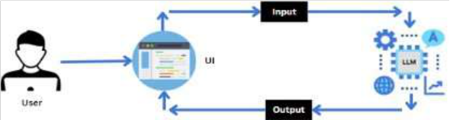

User Stories for Explore with AI

User Type | Functional Requirement (Epic) | User Story Number | User Story / Task | Acceptance Criteria | Priority | Release
Customer  (Web/Mobile) | Input Travel Details | USN-1 | As a user, I can enter my travel destination. | I can input a destination and it is accepted by the system. | High | Sprint-  1
Customer  (Web/Mobile) | Input Travel Details | USN-2 | As a user, I can enter my trip duration (days/nights). | I can input start/end dates or number of days and it is validated. | High | Sprint-  1

Customer  (Web/Mobile) | Input Travel Details | USN-3 | As a user, I can select my travel preferences/interests. | I can select categories like sightseeing, adventure, food, or relaxation. | High | Sprint-  1
(Web/Mobile) | AI Itinerary Generation | USN-4 | and receive a personalized itinerary. | including attractions, dining, and tips. | High | 2
Customer  (Web/Mobile) | Itinerary Review | USN-5 | As a user, I can review the generated itinerary. | I can see each day’s schedule clearly and verify details. | High | Sprint-  2
Customer  (Web/Mobile) | Itinerary Customization | USN-6 | As a user, I can edit or adjust activities in my itinerary. | I can modify activities, timing, or remove items and see the changes reflected. | Medium | Sprint-  3
Customer  (Web/Mobile) | Itinerary Export | USN-7 | As a user, I can export or copy the itinerary. | I can download as PDF or copy to clipboard for offline use. | Medium | Sprint-  3
Customer  (Web/Mobile) | Error Handling | USN-8 | As a user, I receive error messages for invalid or empty inputs. | The system shows a friendly error message and prompts corrections. | High | Sprint-  4
Customer  (Web/Mobile) | Recommendations | USN-9 | As a user, I can view optional AI- suggested attractions or hidden gems. | AI provides recommended spots based on destination and interests. | Low | Sprint-  4

